LAB 1

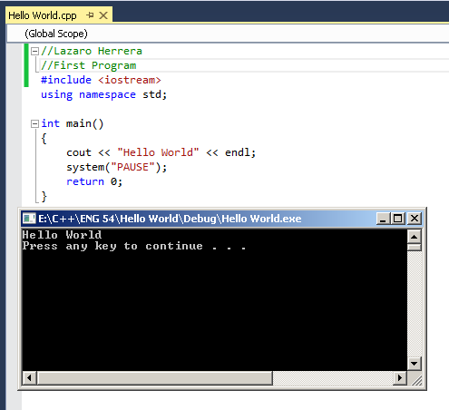

LAB 1: Programming Output

1. 6 \* 7 = 42
2. Hello

World

LAB 1: Programming

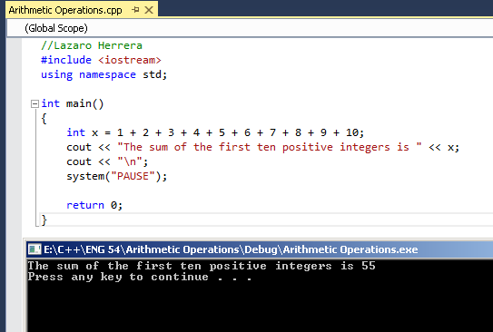

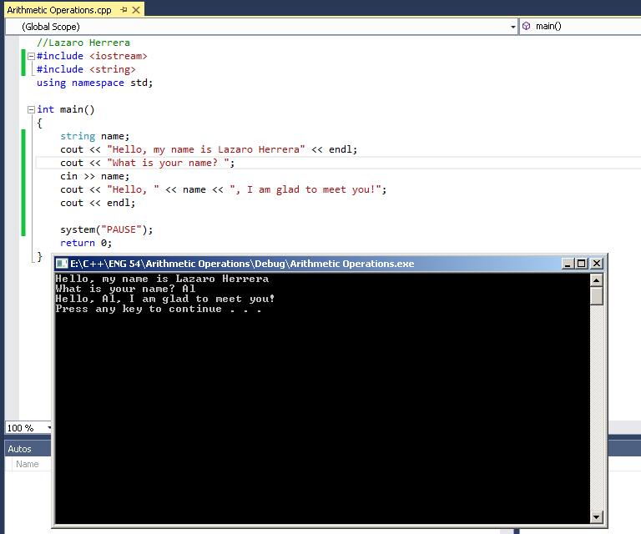

Fill in the blanks

1. Main
2. { }
3. Semicolon
4. Newline

LAB 2: Programming Output

1. 63
2. 39
3. Please enter an integer: 5

Hello

LAB 2: Programming

